SE – Overview of IT Industry
1. What is software? What is software engineering?
Software is a program or set of programs containing instructions that provide desired functionality. Engineering is the process of designing and building something that serves a particular purpose and finds a cost-effective solution to problems.
software engineering
Software Engineering is the process of designing, developing, testing, and maintaining software. It is a systematic and disciplined approach to software development that aims to create high-quality, reliable, and maintainable software.
2. Explain types of software
Software can be categorized into two main types: application software and system softwar.
1) Operating system
2) Utility software
3) Programming software
4) Word processor
5) Database software
6) Language processors
7) Multimedia software
8) Spreadsheet software
3. What is SDLC? Explain each phase of SDLC
The Software Development Life Cycle (SDLC) is a process used by software development organizations to plan, design, develop, test, deploy, and maintain software applications.
1. Planning & Requirement Analysis
Identify security requirements.
Select security measures to counter threats and vulnerabilities.
2. Architectural Design
Apply security design principles.
Conduct threat modeling, access control, encryption, and risk analysis.
3. Software Development & Testing
Perform code reviews for standard compliance.
Run security tests like penetration testing.
4. Deployment
Use automated DevSecOps tools.
Configure firewalls, access controls, and security settings.
5. Maintenance
Continuously monitor for vulnerabilities.
Update software with security patches.
4. What is DFD? Create a DFD diagram on Flipkart
DFD is the abbreviation for Data Flow Diagram. The flow of data of a system or a process is represented by DFD. It also gives insight into the inputs and outputs of each entity and the process itself. DFD does not have control flow and no loops or decision rules are present
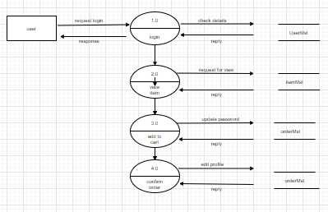

5. What is Flow chart? Create a flowchart to make addition of two numbers
A flowchart is a diagram that depicts a process, system or computer algorithm.
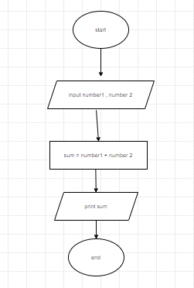
6. What is Use case Diagram? Create a use-case on bill payment on paytm.
Use-case diagrams describe the high-level functions and scope of a system. These diagrams also identify the interactions between the system and its actors.
